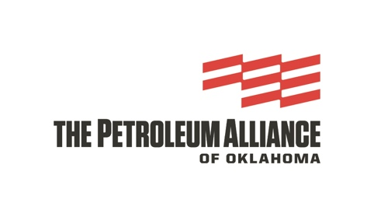

**THE PETROLEUM ALLIANCE OF OKLAHOMA**

**FUTURE LEADERS**

**CLASS OF 2025 APPLICATION**

**Name:**

**Company:**

**Title:**

**Mailing Address:**

**Email Address:**

**Telephone Number:**

1. Summarize your employment history and experience; include jobs held, dates of employment, and essential functions of each position. 250 words maximum.
2. Share your personal journey. Listed are a few guiding questions, but please write what is most meaningful to you. Where did you grow up? What experiences or challenges shaped you? Who were influential people in your life? 250 words maximum.
3. Explain your interest in the Future Leaders program and how you anticipate it will impact your oil and natural gas industry career. 250 words maximum.
4. Describe your future dreams and goals, both personal and professional. 250 words maximum.

By submitting this application, you verify the information contained within is accurate and that you have read and understand the application requirements found online at thepetroleumalliance.com, participant requirements and standards for eligibility.

Submit completed application and one letter of recommendation from an executive or immediate supervisor at your company. All submissions must be emailed to Annie Parks, Membership and Marketing Coordinator, at annie@okpetro.com by Oct. 21, 2024.